Operational Concept Description

Online Wedding Management System (OWMS)
Team 12
Prepared For: Mrs. Samta Jain

Prepared by Project Team

Project Manager: Rathin Kumar
System Architect: Amala Rangnekar
Life Cycle Planner: Kristen Morse
Requirements Lead: Rajani Thakur
Operational Concept Lead: Divya Yellapragada
Feasibility Analyst: Kayomars Batliwala
IV&V: Kristopher Reynolds

Version History
Date | Author | Ver | Changes made | Rationale
09/26/20 | DY | 1.0 | - Initial version of OCD | - Initial Document for Evaluation Phase
09/27/13 | DY | 1.0 | - Initial version of OCD  with final changes | - Initial Document for Evaluation Phase
10/15/13 | DY | 1.1 | - Proposed New Operational Concept, System Objectives, Constraints and priorities | - Final version document for Valuation Phase
10/23/13 | DY, KB, RT | 1.2 | - Changed Program Model, Benefits Chain Diagram, System Boundary Diagram, Updated Capability Goals and Constraints | - ARB Comments
12/02/13 | DY | 1.3 | - Changed Program Model,  Benefits Chain Diagram,  System Boundary Diagram,  Business Workflow Diagram  Updated Capability Goals and Constraints | - TA’s comments and ARB feedback
12/09/13 | DY | 1.4 | - Added all external components to System Boundary Diagram | - Added Functionalities to the system.

Table of Contents
Version History 2
Table of contents 3
Table of tables 4
Table of figures 4
1. Introduction 5
1.1 System overview and purpose 5
1.2 Status of OCD 5
2. Vision 6
2.1 Program model 6
2.2 Benefits Chain Diagram 7

2.3 System Capability Description………………………………………………………..8
2.4 System Boundary and Environment Diagram 9
3. System transformation 10
3.1 Information on the current system 10
3.1.1 Infrastructure 10
3.1.2 Artifacts 10
3.1.3 Current Business Workflow…………………………………...……………10
3.2 System Objectives, Constraints, and Priorities………...……………………….................11
3.2.1 Capability Goals .............................................................................................................11
3.2.2. Level-of-service Goals ...................................................................................................11
3.2.3 Organizational Goals .....................................................................................................11
3.2.4 Constraints ....................................................................................................................11
3.2.5 Relation to current system............................................................................................ 11
3.3 Proposed new operational concept ....................................................................................... 12
3.3.1Element Relationship Diagram ...................................................................................... 12
3.3.2 Business Workflow Diagram ..........................................................................................13
3.4 Organizational and Operational Transformations ..............................................................14
3.4.1 Organizational transformations ...................................................................................14
3.4.2 Operational transformations .....................................................................................
....14

Table of Tables
3.2.1 Capability Goals……………………………………………………………………………….…..11
3.2.2 Level-Of-Service Goals……………………………………………………………………….…...11
3.2.3 Organizational Goals…………………………………………………………………….…………11
3.2.4 Constraints………………………………………………………………………….…….….……..11

Table of Figures
Figure 1: Benefits Chain Diagram………………………………………………………………… 7
Figure 2: System Boundary and Environment Diagram……………………………………………9
Figure 3: Element Relationship Diagram…………………………………………………………...12
Figure 4: Business Workflow Diagram……………………………………………………………..13

1. Introduction

1.1 Purpose of the OCD
This document details the success-critical stakeholders’ shared vision and goals for “Online Wedding Management System (OWMS)”. The stakeholders are Mrs. Samta Jain, as Product owner, USC Development Team, Bride and Groom, as users and Maintainer.

1.2 Status of OCD
The status of OCD is at version 1.3. All sections are complete, ready for TRR ARB. The faults fixed are inconsistency in Program Model, Benefits Chain Diagram, System Boundary Diagram from the comments given in the previous ARB.

2. Shared Vision

Program Model
The following section is a breakdown of the overall program model as understood by the development team during win-win negotiation sessions.

Assumptions
- People are willing to use an online wedding management system to substitute the traditional system.
- The couple would want to design their own card without help from professional designers.
- Everyone has internet access and email address.

Stakeholders  (Who) | Initiatives  (What) | Value Propositions  (Why) | Beneficiaries  (For Whom)
- Product owner  - Development team  - Bride and Groom  - Maintainer | - Providing libraries filled with content specific to Punjabi culture (icons, background images)  - Facilitate emailing invitations  - Designing a database that keeps track of RSVP information  - Create and execute marketing strategies in order to promote product to Punjabi couples  - Hire a maintainer  /developer to maintain the website | - Decrease  time in creating invitation cards for Punjabi couple and decreases time and costs in sending invitations to guests.  - Decrease  time in  managing of guest list and RSVP  - Increase amount of users of product in order to eventually make profit | - Bride and groom  - Product Owner

Cost  -Hosting website on Amazon Web-Services  -Marketing cost | Benefits  -Save cost of sending physical invitation (especially to guests in distant countries)  -Saves time of sending the invitation and waiting to receive the reply

Table 1: Program Model

2.2 Benefits Chain Diagram

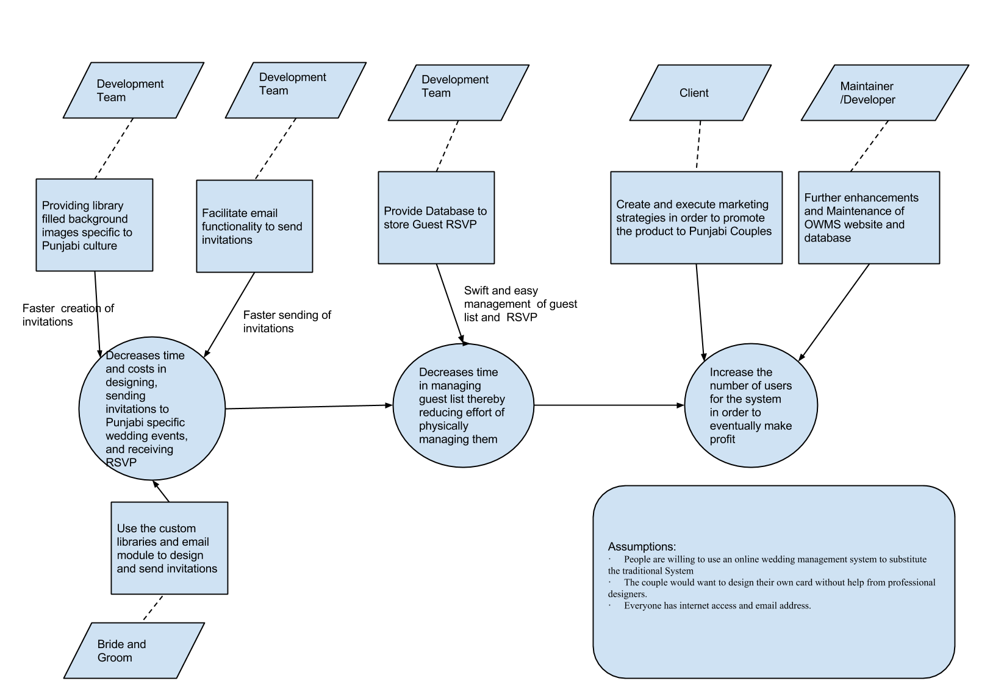

Figure 1: Benefits Chain Diagram

2.3 System Capability Description

“Online Wedding Management System” is an online application that Indian Punjabi couples can use to design and send invitations, and communicate with guest about the couple’s upcoming wedding. The system will provide a means for the engaged couple to design and distribute an electronic wedding invitation via email, reducing time and cost. By having a database exclusively to track the RSVP from guests, the couple can save a lot of time in organizing the guest list.

There is no existing system. Everything is built from scratch.

2.4 System Boundary and Environment Diagram
Figure 2 shows a diagram of the system to provide an overhead view of the boundaries of the system and the entities it interacts with. The features allow the couple to interact with their guests, friends, and family though the features in the system.
For a more detailed look at these features in section 2.3.1
Figure 2: System Boundary and Environment Diagram
- Design invitation card
- Dragging and dropping
- Saving content and design dynamically
- Toggle invitation backgrounds
- Upload guest list
- Sending and receiving RSVP via emails.
- Providing library of Punjabi icons, background images.
- Couple and Event Information Questionnaire
- Provide English to Hindi translation support for certain text on invitation card.

Couple
Google Translator

Recaptcha
Library

Guests
Of
Couple

PHP Swift Mailer

- MySQL
- PHP
- JQuery
- JQueryUI
- HTML/CSS
- Ajax
- PHP STORM(IDE)

Maintainer
AWS

Internet

2.3.1 Entities in System Boundary Diagram:

List of services provided:
- Design invitation card
- Dragging and dropping
- Saving content and design dynamically
- Upload guest list
- Sending and receiving RSVP via emails.
- Providing library of Punjabi icons, background images.
- Couple and Event Information Questionnaire
- Google translation from English to Hindi for certain text.

List of support infrastructure:
- MySQL
- PHP
- JQuery, JQueryUI
- HTML/CSS
- Ajax
- PHP STORM(IDE)

Service Users:
- Couple
- Guests
System administration users:
- Maintainer
External Sources:
- AWS
- Google Translator
- Recaptcha Library
- PHP Swift Mailer

3. System Transformation
3.1 Information on current system

3.1.1 Infrastructure
The website is written in PHP, JQuery, JQueryUI, HTML, CSS and Ajax. The site is hosted on AWS EC2. The database is hosted on Amazon Web Services (AWS) RDS that supports 20 GB of storage and 20GB of backup for database.

3.1.2 Artifacts
- Wedding invitation templates and icons

3.1.3 Current Business Workflow
We don't have an existing system. Everything is being built from scratch.

3.2 System Objectives, Constraints, and Priorities

3.2.1 Capability Goals

ID | Capability Goal | Priority Level
CG-1 | Upload list of guest details by couple | Must Have
CG-2 | Capability to get information from user by providing Event and Couple Information questionnaire | Must Have
CG-3 | Drag and Drop Functionality | Must Have
CG-4 | Saving the invitation card design and content after each session | Must Have
CG-5 | Dynamically save text content and update the database | Must Have
CG-5 | Providing Libraries of icons and background images. | Must Have
CG-6 | Send and receive RSVP via email | Must Have
CG-6 | Toggle Invitation Backgrounds | Should Have
CG-7 | Use Google translate to provide dual language support | Would Like

3.2.2 Level-Of-Service Goals
ID | Level-Of-Service Goals | Desired Level | Acceptance Level | Win Condition
LOS-1 | Availability of the system(In terms of number of hours per day) | 24hrs/day | 20hrs/day | WC_2811
LOS-2 | Number of concurrent users | 50 | 40 | WC_2925

3.2.3 Organizational Goals
ID | Organizational Goal
OG-1 | Providing a blend of traditional and modern Punjabi culture
OG-2 | Usage of OWMS as a start-up company

3.2.4 Constraints

ID | Constraints
C-1 | Only registered members can use the system
C-2 | Memory Usage restriction for each couple(amount of data they can upload)  Instead should be not enough storage on AWS
C-3 | Use of modern browsers(minimum IE-10+ /Firefox 17+/Chrome 20+)
3.2.5 Relation to Current System
Since we are building the system from scratch there is no relation to current existing system.

3.3 Proposed new Operational Concept

3.3.1 Element Relationship Diagram

Couple
Couple’s
Guest Information Files

Database

Wedding Information
Module

Access
Update
Couple’s
Data

Design and Save
Invitation

Authentication
Wedding
Invitation
Module
Login
Background images, Icons
Access

Email invitation
Email Module

Invitation cards
Access

View Guest RSVP
RSVP
Module

Access
Guest Information

RSVP
Information
Access and Submit
RSVP
Save Guest RSVP

Guests
RSVP
Link
In the email

Figure 3: Element Relationship Diagram

USER | SYSTEM
YES

NO

NO

Couple faces the login/register screen
Couple registers with the system
Couple provides login credentials
YES
Upload Guest List
Design Invitation
and save
Email
Invitation
Update Wedding, event details
View Guest
RSVP
Creates profile for the couple and stores the login information
Verifies login credentials
START
Is a member?
Login credentials valid?
STOP

Figure 4: Business Workflow Diagram

3.4 Organizational and Operational Transformations

3.4.1. Organizational Transformations
A maintainer/future developer is needed to maintain the database and resolve problems that arise in maintaining the website and database.

3.4.2 Operational Transformations
The Punjabi couple can set up a website to reach out to their wedding guests with an electronic invitation, and a place customized for them to send their guests to learn more information.
Upon getting to the OWMS the couple will create an account. They will be asked for typical information such as family names, venue, and other wedding details. There will also be questions regarding their cultural background and preferences. Once the questionnaires are complete a website will provide each party a URL to use to direct their family to. This will be the front facing site they can use to keep guests up to date on the events regarding the wedding.
Now that the couple has created and personalized website and their invitation, they can update guests on locations and times of Haldi, Mehndi, Sangeet, Wedding and Reception.

